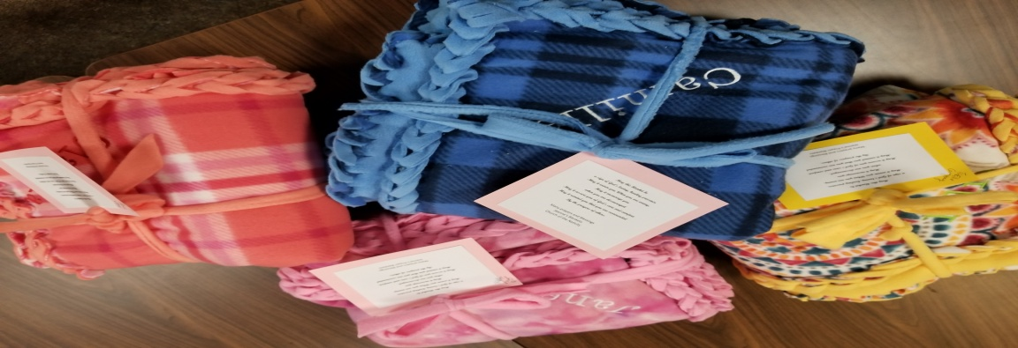
Jeanne's Prayer Blanket Order Form
Your Name:
Your Phone:
Your Email Address:
Name of Blanket Recipient: All blankets will be embroidered with the person’s first name

Please circle one:
Male Female
Please circle one:
Child Adult
Blankets being requested for registered parishioners are at no cost. For those blankets being requested for non-parishioners, we ask for a donation of $25 to cover cost of fabric.
If you would like your blanket mailed, there is an additional box/mailing fee of $12.
Address of Recipient: If we are mailing on your behalf

Make checks payable to: Church of the Nativity, 180 Ridge Road, Fair Haven, NJ 07704

